Rex Tincher  3304 Carrier Avenue  Dayton, Ohio 45429  Phone 937-298-3978  Email rex@tincher.to | 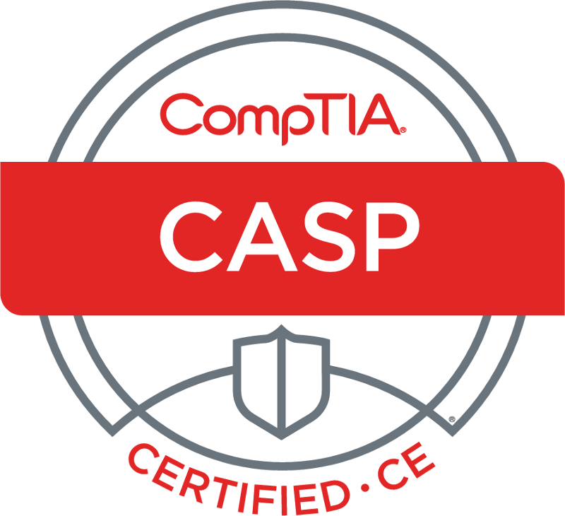 | 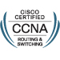 | 
 |  | 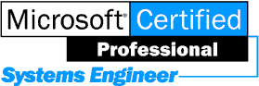

Objective

Cybersecurity Analyst near Dayton Ohio USA

Qualifications Summary

Qualifications include CASP cyber security certification, Security+ certification, Microsoft Windows certification and experience, Linux experience, Cisco CCNA and CCENT computer networking certifications, and a BS degree in Computer Science.

Experience

Cybersecurity Analyst, National Technologies Associates, Dayton, Ohio | 2015 to present
- Working as Information Systems Security Manager (ISSM).
- Converting systems from DIACAP to Risk Management Framework (RMF) process using eMASS.
- Earned CompTIA Advanced Security Practitioner (CASP) CE on 19 June 2017.

Self-Study | 2015
- Cyber Resiliency Symposium at Advanced Technical Intelligence Center (ATIC) on 29 October 2015.
- Earned Security+ CE certification on 3 September 2015 - satisfies DoD 8570.1M IAT Level II.
- Earned Cisco CCNA computer networking certification on 30 July 2015.
- Earned Cisco CCENT computer networking certification on 18 June 2015.

College Student, Sinclair College, Dayton, Ohio | 2014
- Took classes for the Cisco Certified Network Administrator (CCNA) certification.

System Administrator, Stress Engineering Services, Mason, Ohio | 2006 to 2013
- Managed network of 100 Windows and Linux computers and supported users.
- Created accounts, installed software, installed patches, purchased and configured new servers, etc.
- Selected and procured Silicon Mechanics Linux-based (CENTOS) HPC computer cluster for simulations.
- Planned and oversaw successful relocation of all SES Mason office IT resources to new building, including new Internet connection, new phone service, and new phone system, over a weekend.
- Leveraged Mitel competitive upgrade program to obtain discount on new Mitel 5000 HX phone system.
- Protected employees from spyware with Barracuda Web Filter 310.
- Reduced copy machine cost from 14 cents per color page down to 5.5 cents per color page.
- Protected critical engineering data with HP MSL2024 tape library and LTO5 tapes.
- Supported Abaqus, Active Directory, Cisco, Commvault Simpana, Dell, Falcon facility monitoring system from RLE Technologies, Fluent, HP, High Performance Computing (HPC), Inter-Tel, Linux (CENTOS and Red Hat), Microsoft Office, Mitel phone systems, Polycom HDX 5000 videoconferencing, Solidworks, Symantec Antivirus, TCP/IP, Windows 2003, Windows 2008, Windows XP, Windows 7, and dozens of other engineering software programs

Rex Tincher | Page 2 of 2
3304 Carrier Avenue
Dayton, Ohio 45429
Phone 937-298-3978
Email rex@tincher.to

Experience continued

Network Administrator, Barrystaff (temp job), Dayton, Ohio | 2006
- Subcontracted to Vartek for nine weeks during Vartek’s busy season.

Senior Systems Engineer, Quanexus (was PC Solutions), Dayton, Ohio | 2004 to 2005
- Increased productivity by documenting and sharing network configurations.
- Supported Active Directory, Exchange, Ghost, Linksys, Microsoft Office, Microsoft SBS, Norton Antivirus, TCP/IP, Veritas Backup Exec, Windows 2000, Windows 2003, and Windows XP.

Network Engineer, Gasper Corporation (subsidiary of NCR), Dayton, Ohio | 2000 to 2003
- Supported TCP/IP network, setup and maintained servers, and fixed user problems at the desktop.
- Reduced typical PC setup time from 10 hours to 4 hours by documenting and automating procedure.
- Supported Active Directory, Microsoft Office, TCP/IP, VMware, Windows 2000, and Windows XP.

Network Administrator / Programmer, Spectra Research, Dayton, Ohio | 1996 to 1999
- Designed and installed Local Area Network (LAN) in new office.
- Developed configuration management (CM) module for software re-use program.
- Created mixed-language FORTRAN / C++ programs that accessed Poet object-oriented database.

Senior Systems Analyst, LOGTEC, Fairborn, Ohio | 1994 to 1996
- Designed and developed Software Problem Report (SPR) tracking system in Remedy ARS.
- Built Process Change Request (PCR) tracking relational database in Microsoft Access.
- Created database Entity-Relationship (ER) diagrams and documented user software requirements.
- Did data modeling and data mapping and analyzed process flow and data flow.

Additional work history available upon request.

Certification

CompTIA Advanced Security Practitioner (CASP) CE awarded 19 June 2017
- satisfies DoD 8570.1M IAM Level II, IASAE Level II, IAT Level III.
CompTIA Security+ CE certification awarded 3 September 2015
- satisfies DoD 8570.1M IAM Level I and IAT Level II.
Cisco CCNA computer networking certification awarded 30 July 2015.
Cisco CCENT computer networking certification awarded 18 June 2015.
MCSE (Microsoft Certified Systems Engineer)

Education

Bachelor of Science in Computer Science, Christopher Newport University, May 1994.

Security

US Citizen. Secret Clearance.

